Oracle Administration Services

Oracle In-Doubt Transactions

Submitted to



By



CIS, Wipro Limited

Document Details

Project Name | Innogy SE
Account | CIS
IT Component/Application Title | Oracle In-Doubt Transactions
Current Version | 1.1
List of Contributors | Jiten Pansara
Customer Contact Information

Version History
(All revisions made to this document must be listed in chronological order. All revisions must be approved. Review and Approval can be done by an internal source or by the customer)
Version | Date of Revision | Description | Author | Reviewed By | Approved By
1.0 | 20-02-2018 | Initial Draft | Jiten Pansara | Balaji Ankalle | Santosh Badiger
1.1 | 20-12-2018 | Updated the content | Sreya Puthukudy | Jiten Pansara | Santosh Badiger

Document Distribution List
S.No | Name and Company | Purpose
1 | RWEIT-ORACLEDBA | This document provides information related to In-Doubt Transaction and how to kill it.
2

TABLE OF CONTENT
1. Purpose 5
3. About IN-Doubt Transaction 5
4. Process to CLEAR the transaction 8

Purpose
This document is prepared for providing information about In-Doubt Transactions of Oracle. Generally, we face this issue in DTS Systems.

About In-Doubt Transaction
Unlike a transaction on a local database, a distributed transaction involves altering data on multiple databases. Consequently, distributed transaction processing is more complicated, because Oracle must coordinate the committing or rolling back of the changes in a transaction as a self-contained unit. In other words, the entire transaction commits, or the entire transaction rolls back.

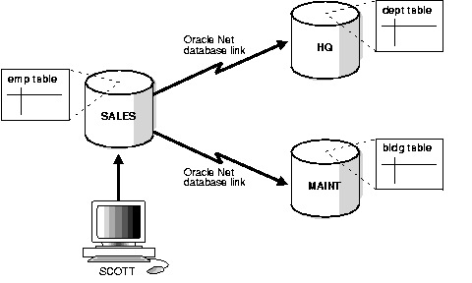

The following distributed transaction executed by scott updates the local sales database, the remote hq database, and the remote maint database:

UPDATE scott.dept@hq.us.acme.com
SET loc = 'REDWOOD SHORES'
WHERE deptno = 10;
HQ.US.ACME.COM is a DBLINK

UPDATE scott.bldg@maint.us.acme.com
SET room = 1225
WHERE room = 1163;

The two-phase commit mechanism ensures that all nodes either commit or perform a rollback together. What happens if any of the three phases fails because of a system or network error? The transaction becomes in-doubt.

Distributed transactions can become in-doubt in the following ways:
- A server machine running Oracle software crashes
- A network connection between two or more Oracle databases involved in distributed processing is disconnected
- An unhandled software error occurs
The RECO process automatically resolves in-doubt transactions when the machine, network, or software problem is resolved. Until RECO can resolve the transaction, the data is locked for both reads and writes. Oracle blocks reads because it cannot determine which version of the data to display for a query.

Process to Clear In-Doubt Transactions
You may face below error:
- ORA-01591: lock held by in-doubt distributed transaction 1.21.17
Resolution of in-doubt transactions can be complicated. The procedure requires that you do the following:
- Identify the transaction identification number for the in-doubt transaction.
- Query the DBA_2PC_PENDING and DBA_2PC_NEIGHBORS views to determine whether the databases involved in the transaction have committed.
- If necessary, force a commit using the COMMIT FORCE statement or a rollback using the ROLLBACK FORCE statement.

When we have an in-doubt transaction we can perform the following query:
SQL> select * from dba_2pc_pending;

All the pending transactions are going to be listed, the number we are interested in is the LOCAL_TRAN_ID.
To clean an entry we use the following procedure (as sysdba):
SQL> exec DBMS_TRANSACTION.PURGE_LOST_DB_ENTRY('trans_id');

Rollback Script:

This one prepares the rollback script for the transactions:

select 'rollback force '''||local_tran_id||''';' from DBA_2PC_PENDING where state='prepared'

At last run the rollback with the transaction id:

rollback force '29.34.42726';

